

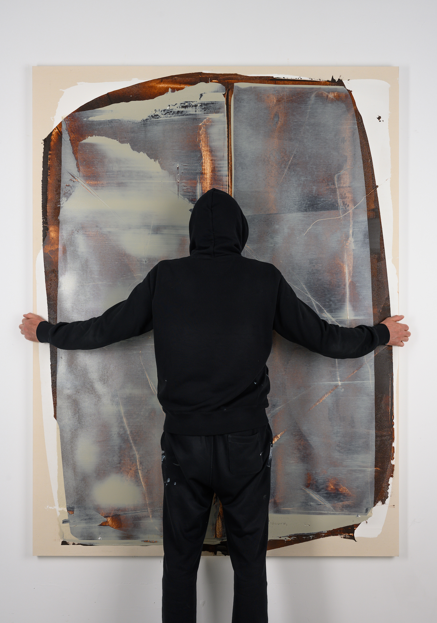

Alex Kuznetsov
Another Output
22 April — 23 May, 2021

Parallel event of Program Art Moscow × 46th Russian Antique Salon

Triumph Gallery presents the solo show by Alex Kuznetsov, Another Output, featuring paintings and drawings. Born in the city of Minsk, Alex has created art from the very early childhood. As an artist, he began with graffiti, garnering acclaim both in Russia and Internationally. He was the founder of the well-known True Stilo crew. In 2010, he made a complete transition to studio work, focusing on abstract painting. Alex explores the interplay of colours, the rhythm and dynamics that immerse the artist into a meditative flow where the process is as important as the result. Following the vibrations of colour and fully committing to the work process, Alex brings final form to the work with a palette knife.

The series on display show the form and color merge together, move together and interact, with inclusion of some isolated semblances of the urban landscape — outlines of futuristic cars, helmets, skies riddles with skyscrapers spires. Abstract art grant independence to the materials and the medium where they act as characters in the story of an equal footing. Drawing inspiration from Gerhard Richter’s layered brushwork, Barnett Newman’s colour fields, Pierre Soulages’ ultra-black, the artist creates unique art that astounds the audience with its inner energy.

Alexey’s artistic practice relies on smooth movement of the equipped hand, where the flow rate of paint sets a certain framework and where washing-out of colour is equivalent to its intuitive application. The artist studies the state of presence and the phenomenon of memory, carefully balancing between control and spontaneity.

Alexey’s paintings are a continuous pursuit of the ideal, a manifestation of the desire to align the world with an inner sense of harmony. The artist does not provide any explanation for his abstractions: instead, he sublimates his visions of the canvas, leaving it up to the viewer to interpret the images and potentially associate with them.
_______________________
Alex Kuznetsov was born in Minsk in 1978. As a young man, he worked as a graphic designer, and had a first go at graffiti in 1997. He had personal exhibitions at Lida State Museum of History and Art, Belarus National Centre for Contemporary Arts, Speerstra Gallery (Switzerland), MSK Eastside Gallery (Moscow), Mirus Gallery (San Francisco). His works are regularly featured at international exhibitions and held in private collections in New York, San Francisco, London, Seoul, Hong Kong, Brussels, Geneva, Paris, Monaco, Barcelona, Moscow and Minsk.

